LONGFIELD & NEW BARN PARISH COUNCIL
www.longfieldandnewbarnpc.kentparishes.gov.uk
Parish Clerk:
Mike Morgan

Tel/Fax: 01474 707290
longfieldparishcouncil@btconnect.com
Office: 1st Floor
Long Valley Hall
Fawkham Road
Longfield
Kent DA3 7QP
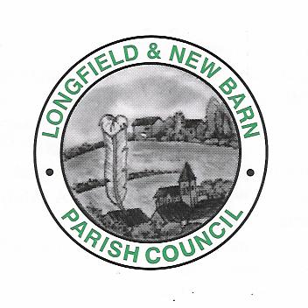
Annual Parish Meeting (On-line via Zoom on Tuesday the 25th of May 2021:
Start: 19:00
Present: Cllr. Jeremy Kite (Chair), Cllr. Steve Brown, Cllr J. McDonald, Cllr. G. Holt, Cllr. M. Tamber, Cllr. C. Stafford Cllr. R. Perfitt, Cllr. J. Denman, Cllr. G. Sandher & Cllr. T. Mack.
Clerk: M. Morgan
1AGM/2021: Apologies for absence: Cllr. P. Denman,
2AGM/2021: Members of the public present = None.
3AGM/2021: Declarations of Interest:
Cllr. Kite is Leader of Dartford Borough Council and member of Leigh Academy Trust.
Cllr. Brown is a member of Dartford Borough Council, a member of the DBC cabinet and a member of the Development Control Board at DBC.
Cllr. Perfitt is a member of Dartford Borough Council and the Development Control Board.
Cllr. Mack has an interest in land between Pincroft Wood & Main Road, New Barn.
Cllr. Tamber is a property owner in Station Road, Longfield.
4AGM/2021: Chair’s report:
Councillor Jeremy Kite declared an interest as a member of the executive of the Dartford Borough Council, Kent County Council, an interest in Leigh Academy Trust; and as a director of Dartford Football Club.
Councillor Steve Brown declared an interest as a member of the Development Control Board and Cabinet member of Dartford Borough Council.
Councillor Roger Perfitt declared an interest as a member of the Development Control Board and member of Dartford Borough Council.
The Chair outlined that his written report had been sent to Member’s and is now in the public domain.

Cllr. Sandher stated that we should be proud of supporting the local businesses this year and Cllr. Kite added that this was Cllr. Paul Denman’s idea and he should be given credit for this.
Cllr Kite added that there is now £2m in government business support which Dartford are managing locally.

Cllr. Kite stated that there were big issues ahead, the Long Valley Hall is one and we hope to re-open in a few weeks and start receiving income from it. It is a pity that so much money has had to be spent on the foundations and other issues that cannot be seen by the public, but we will have a brand-new hall.

Parking is likely to return as an issue as businesses and commuters return to work. This will have to be examined in full by the Parish Council in conjunction with Dartford Borough Council.

5AGM/2021: Financial report:
The Clerk presented the accounts (copy attached) and explained the variances in expenditure, account balances etc. The Council actually came in within budget, but reserves were sued in the renovation of the hall. There was no increase in the Parish Council element of the Community Charge.

The audit was being completed by A4G chartered accountants and will be forwarded to PFK Littlejohn. Finances passed by all Councillors present.

Cllr. MacDonald asked why the council had six bank accounts. Two of these now have minimal amounts in them. The Clerk explained that they had until recently a higher amount of cash in them, but these reserves have been used in the hall development. Cllr Kite stated that we needed to keep the accounts live, as they may have a beneficial rate of interest which we may not receive on a new account. In addition, it is better to spread the finances over a number of accounts as the FSA advice is that no amount larger than £85,000 should be held in one account.

6AGM/2021: Election of Chair and Vice Chair.

There were no new nominees and the Chair (Cllr Kite) and Vice Chair (Cllr Brown) were happy to stand again. This was agreed by all Member’s proposed by Cllr. Sandher and seconded by Cllr. Perfitt.

The meeting closed and moved on to the Parish monthly meeting at 7:20pm.

